23.29: a) Point b has a higher potential since it is “upstream” from where the positive charge moves.
b) 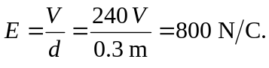
c)

